Lab 3.7.10 - Use Wireshark to View Network Traffic – Windows Version

Topology
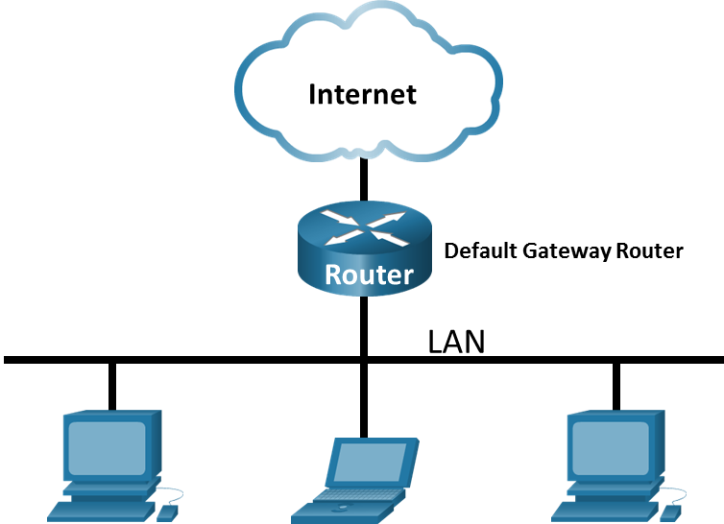

Objectives
Part 1: Capture and Analyze Local ICMP Data in Wireshark
Part 2: Capture and Analyze Remote ICMP Data in Wireshark

Background / Scenario
Wireshark is a powerful protocol analyzer, often referred to as a “packet sniffer.” It captures network traffic so you can see how devices communicate. Network engineers and students often use it for troubleshooting and learning how protocols work.
In this lab, you’ll use Wireshark to capture ICMP packets. ICMP is the protocol used by the Ping command to test if one device can reach another. When you ping, the source sends Echo Requests, and the destination (if reachable) responds with Echo Replies. If it can’t be reached, you may see error messages like Destination Unreachable.
To send data, devices need both an IP address (logical address, e.g., 192.168.1.10/24) and a MAC address (hardware address, e.g., 0e:4a:4b:cc:00:3f). If a device knows the IP but not the MAC, it uses the Address Resolution Protocol (ARP) to find it before communication can happen.
Important: ARP only works within the local network to discover MAC addresses of nearby devices. For devices on other networks, the host cannot learn their MAC address directly. Instead, it sends the frame to the MAC address of the default gateway (router), which then forwards the packet toward the remote destination.

Make sure to read module 3 from NetAcad for background on the concepts covered in this lab.

Required Resources
- 1 PC (Windows with internet access)

Instructions
- Enter your screenshots/answers below the items highlighted in blue and turn in the completed file without making any changes to the original content.
- This Lab cannot be completed using NetLab. Complete using a computer with Internet Access.
- Once the Lab is graded it cannot be resubmitted for a new grade.

Capture and Analyze Local ICMP Data in Wireshark
In Part 1 of this lab, you will ping your local default gateway and capture ICMP requests and replies in Wireshark. You will also look inside the frames captured for specific information. This analysis should help to clarify how packet headers are used to transport data to their destination.

Retrieve your PC interface addresses.
For this lab, you will need to retrieve your PC IP address and its network interface card (NIC) physical address, also called the MAC address.
      - Open a command prompt window used to enter commands on your PC, CMD. You may search for the command prompt utility on a Windows 10/11 PC and run it as an administrator as shown in the screenshot below.
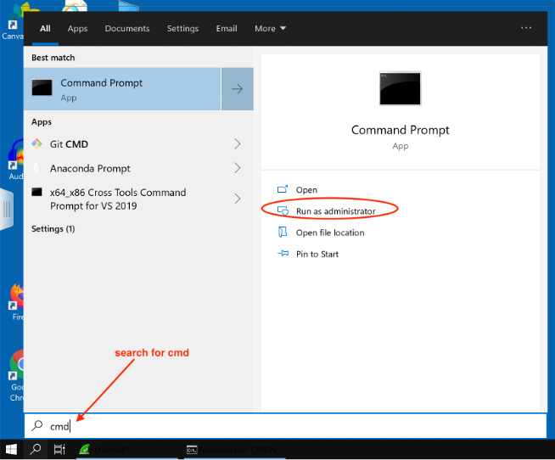

      - In a command prompt window, enter ipconfig /all as shown in the screenshot below:
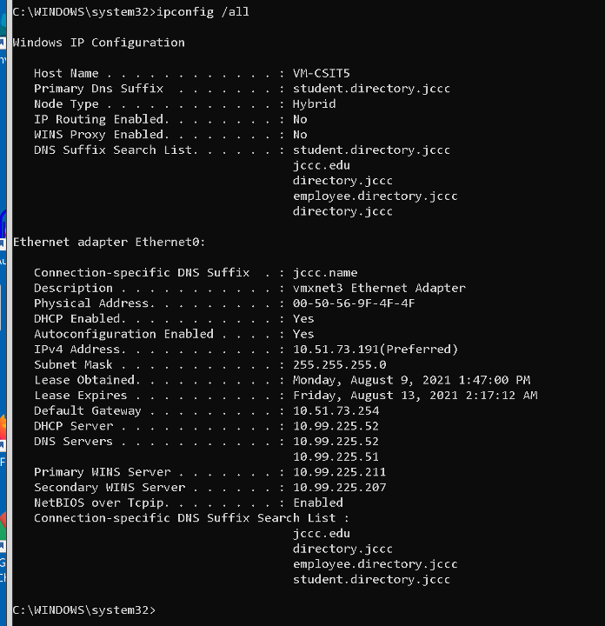

Provide a screenshot like the one above. (10 points)

Record the following information from the screenshot (3 points each):

IPv4 address =
MAC or Physical address =
IPv4 Default Gateway=

Default Gateway is a router which is a networking device that connects separate networks together. Your home default gateway usually is wireless router that connects your home network to your service provide installed on your PC.
Step 2. Install Wireshark if it is not installed on your PC.
      - Go to www.wireshark.org and click Download.
      - Choose the Installer appropriate for your computer operating system.
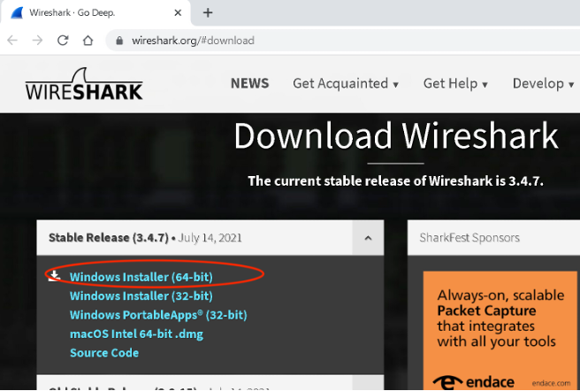

      - Launch the installer program and follow all the default settings to install Wireshark.

Start Wireshark and begin capturing data.
      - Navigate to Wireshark, run it as an administrator:
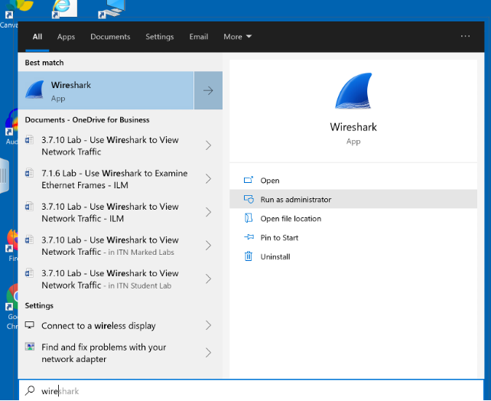
      - Double-click the desired interface to start the packet capture. Make sure the desired interface has traffic activity, see Ethernet0 is the example below. It could be a wired or WiFi interface.
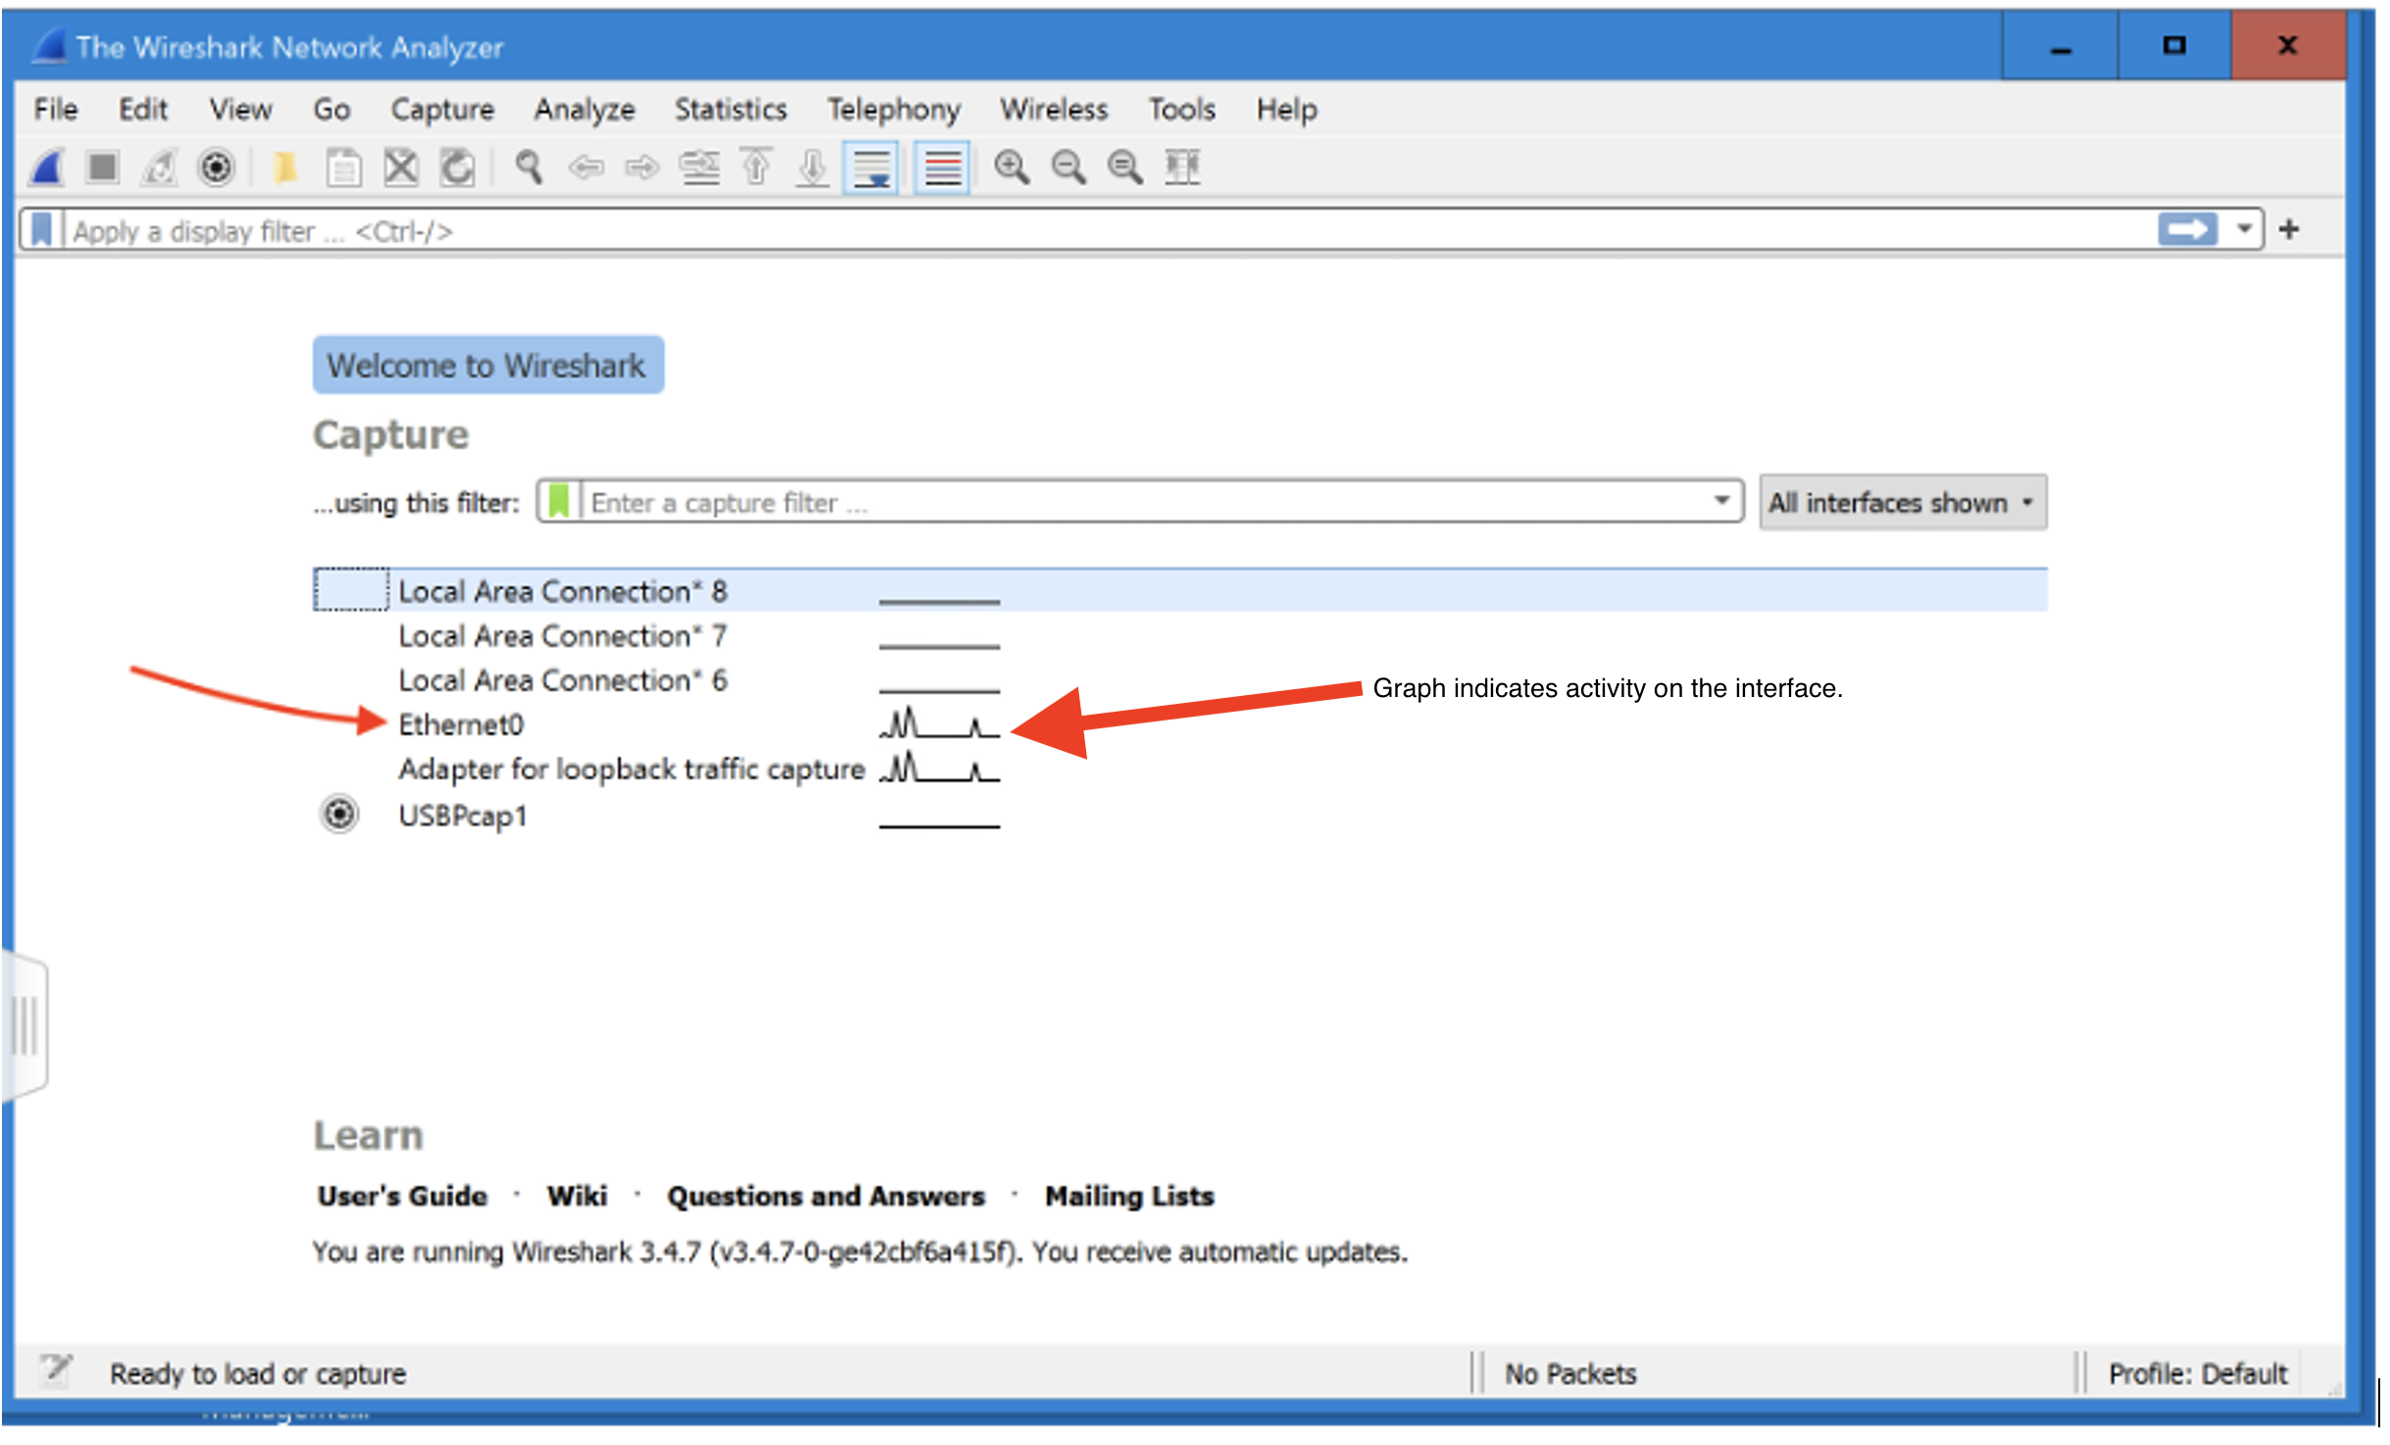

      - Information will start scrolling down the top section in Wireshark. The data lines will appear in different colors based on protocol.
This information can scroll by very quickly depending on what communication is taking place between your PC and the LAN. We can apply a filter to make it easier to view and work with the data being captured by Wireshark.
For this lab, we are only interested in displaying Internet Control Messaging Protocol packets (ICMP) generated because of ping traffic. Type icmp in the Filter box at the top of Wireshark and press Enter and click the Apply button (arrow sign) to view only ICMP (ping) PDUs.
      - This filter causes all data in the top window to disappear, but you are still capturing the traffic on the interface.
      - Navigate to a command prompt window and ping the IP address of the default gateway you recorded in step 1 above.

Provide a screenshot showing the result of the ping. (10 points)

Data will start to appear in the top window of Wireshark again like the screenshot below provided the ping is successful. Note that your Wireshark Window may be arranged slightly different than the screenshot below depending on the version you are running.
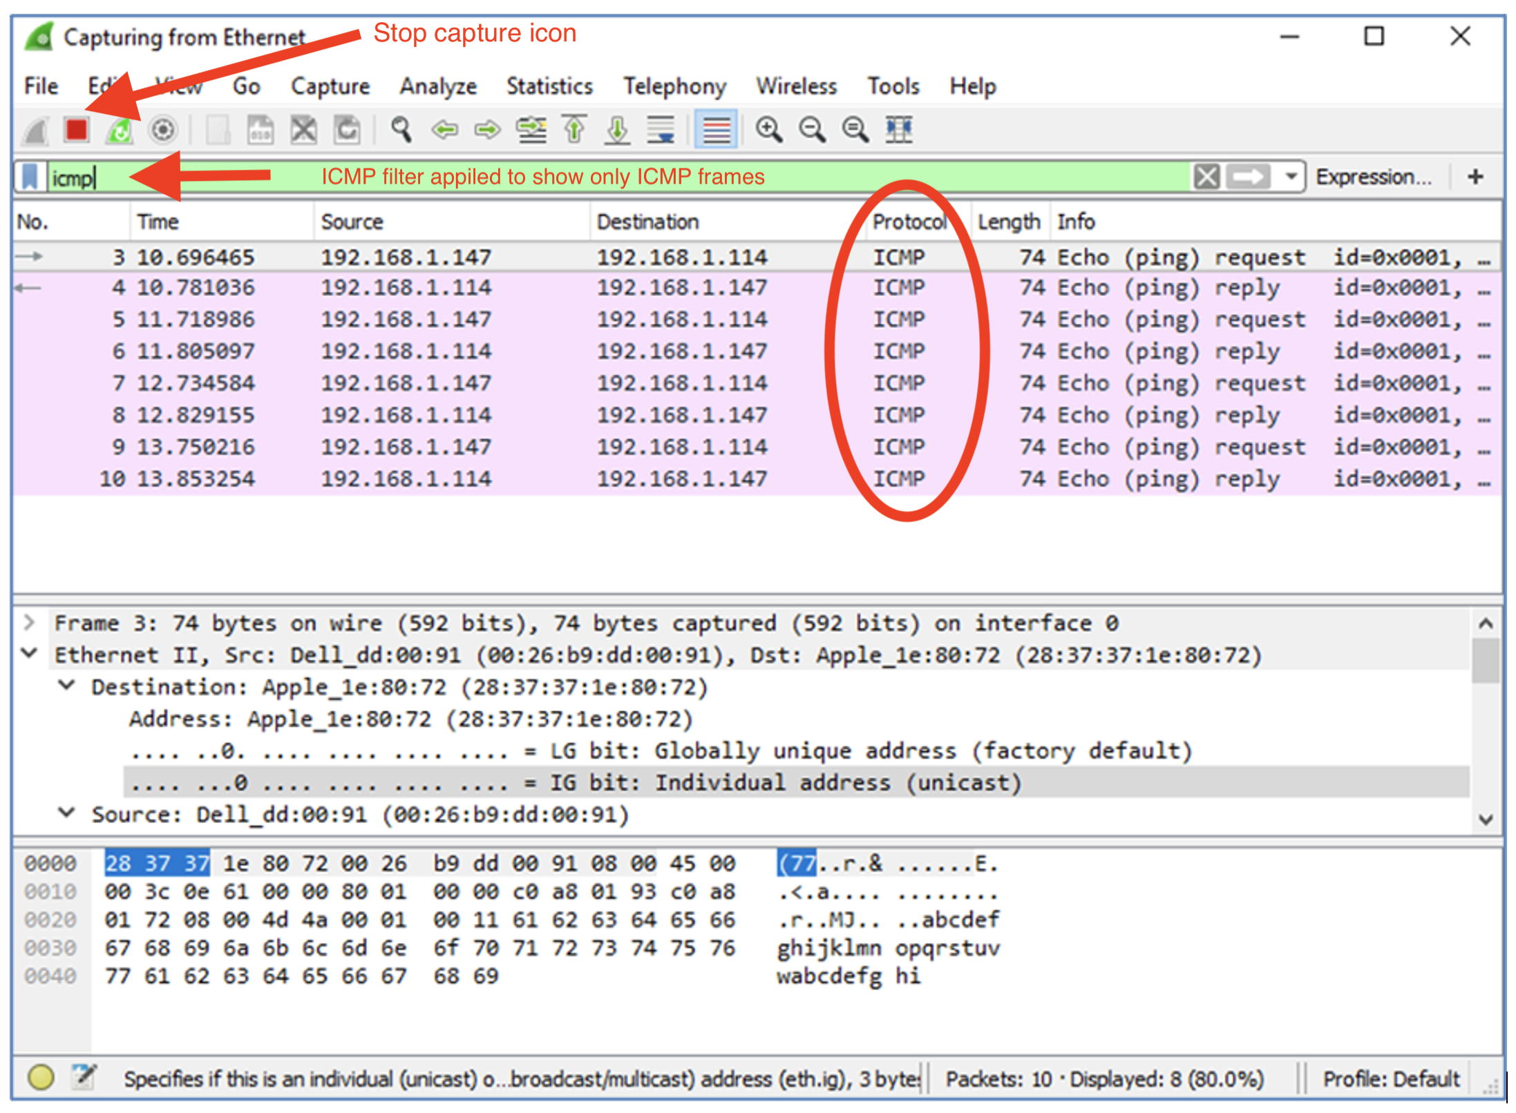

Provide a screenshot like the one above. (10 points)

Note: If the default gateway you are pinging does not reply to your pings, this may be because the PC firewall is blocking these requests. Please see Appendix A: Allowing ICMP Traffic Through a Firewall for information on how to allow ICMP traffic through the firewall using Windows.

      - Stop capturing data by clicking the Stop Capture icon.

Examine the captured data.
Wireshark data is displayed in three sections: 1) The top section displays the list of Protocol Data Unit (PDU) frames captured with a summary of the IP packet information listed; 2) the middle section lists PDU information for the frame selected in the top part of the screen and separates a captured PDU frame by its protocol layers; and 3) the third section displays the raw data of each layer. The raw data is displayed in both hexadecimal and decimal form.
      - Click the first ICMP request PDU frames in the top section of Wireshark. Notice that the Source column has your PC IP address, and the Destination column contains the IP address of the default gateway that you pinged.
      - With this PDU frame still selected in the top section, navigate to the middle section. Click the plus sign to the left of the Ethernet II row to view the destination and source MAC addresses.

Does the source MAC address match your PC interface? (3 points)

What is the destination MAC address, record the value below? (4 points)

How is the MAC address of the pinged default gateway obtained by your PC? (4 points)

Note: In the preceding example of a captured ICMP request, ICMP data is encapsulated inside an IPv4 packet PDU (IPv4 header) which is then encapsulated in an Ethernet II frame PDU (Ethernet II header) for transmission on the LAN.

Part 2: Capture and Analyze Remote ICMP Data in Wireshark
In Part 2, you will ping remote hosts (hosts not on the LAN) and examine the generated data from those pings. You will then determine what is different about this data from the data examined in Part 1.
Note: Computers with newer operating systems prefer to use newer IPv6 addressing over older IPv4, so your pings may not show IPv4 addresses. You can change the capture filter to icmpv6 or force the computer to use IPv4 by adding -4 after the target address you are trying to ping from the command prompt.

Start capturing data on the interface.
      - Start the data capture again.
      - A window prompts you to save the previously captured data before starting another capture. It is not necessary to save this data. Click Continue without Saving.
      - With the capture active, ping the following three website URLs from a Windows command prompt.
        - www.microsoft.com
        - www.cisco.com
        - www.google.com

Note: When you ping the URLs listed, the Domain Name Server (DNS) translates the URL to an IP address. Note the IP address received for each URL.
      - You can stop capturing data by clicking the Stop Capture icon.

Examining and analyzing the data from the remote hosts.
Review the captured data in Wireshark and examine the IP and MAC addresses of the three locations that you pinged. List the destination IP and MAC addresses for all three locations in the space provided.

IP address for www.microsoft.com (5 points)

MAC address for www.microsoft.com (5 points)

IP address for www.cisco.com (5 points)

MAC address for www.cisco.com (5 points)

IP address for www.google.com (5 points)

MAC address for www.google.com (5 points)

Compare the results of the remote pings above to the results of the local ping to the default gateway in Part 1. What is significant about the addressing information you reported above and how does it differ from the local ping information you received in Part 1? (10 points)

Reflection Question

Why does Wireshark show the actual MAC address of the local hosts, but not the actual MAC address for the remote hosts? (10 points)

Appendix A: Allowing ICMP Traffic Through a Firewall
If the members of your team are unable to ping your PC, the firewall may be blocking those requests. This appendix describes how to create a rule in the firewall to allow ping requests. It also describes how to disable the new ICMP rule after you have completed the lab.

Create a new inbound rule allowing ICMP traffic through the firewall.
      - Navigate to the Control Panel and click the System and Security option in the Category view.
      - In the System and Security window, click Windows Defender Firewall or Windows Firewall.
      - In the left pane of the Windows Defender Firewall or Windows Firewall window, click Advanced settings.
      - On the Advanced Security window, click the Inbound Rules option on the left sidebar and then click New Rule… on the right sidebar.
      - This launches the New Inbound Rule wizard. On the Rule Type screen, click the Custom radio button and click Next.
      - In the left pane, click the Protocol and Ports option and using the Protocol Type drop-down menu, select ICMPv4, and then click Next.
      - Verify that Any IP address for both the local and remote IP addresses are selected. Click Next to continue.
      - Select Allow the connection. Click Next to continue.
      - By default, this rule applies to all the profiles. Click Next to continue.
      - Name the rule with Allow ICMP Requests. Click Finish to continue. This new rule should allow your team members to receive ping replies from your PC.

Disabling or deleting the new ICMP rule.
After the lab is complete, you may want to disable or even delete the new rule you created in Step 1. Using the Disable Rule option allows you to enable the rule again at a later date. Deleting the rule permanently deletes it from the list of inbound rules. On the Advanced Security window, click Inbound Rules in the left pane and then locate the rule you created previously. Right-click the ICMP rule and select Disable Rule if so desired. You may also select Delete if you want to permanently delete it. If you choose this option, you must re-create the rule again to allow ICMP replies.

